**TO:** Professor Colman

**FROM:** Chengjun Liu

**DATE:** December 3, 2019

**SUBJECT:** GSBA 542 Final Written Memo

**INTRODUCTION**

This memorandum is to assess my development of communication skills this semester, both from my observation and PitchVantage measures, reflect on discrepancy and improvement, and set the next steps.

**AGENDA**

We arrange the schedule of the memorandum as follows:

* Show visible developments I discovered since the start of the course, including presentation skills and communication strategies.
* The trend of PitchVantage assessments match my observations with a few discrepancies.
* PitchVantage helps improve presentation skills for visualization of performance.
* Conclude with three takeaways from GSBA 542.

**SKILL IMPROVEMENT OBSERVATION**

My initial assessment of communication and presentation skills showed my insufficiency:

* According to CDP Memo, my oral communication and audience analysis were lower than 3, implying much space for improvement.
* During consultation with several senior students, they were not satisfied with my variability of pace, pitch, and volume.

Currently, at the end of the course, visible changes in communication skills can be observed:

* Pitch and volume variability has improved. After many practices, pitch and volume were natural to express feelings. My classmates thought that my tone was no longer monotone.
* The pace and the pause now are well controlled. At the start of the class, it was a dilemma because sometimes a sudden stop would break the talking pace. Today I can keep fluency and proper stops, which is visible both to me and the audience.
* I can set suitable strategies for a specific audience for presentations. This part was ranked low in CDP Memo, but now my speeches for technical and general audiences are endorsed by my partners in mock practices.

**MATCH OBSERVATION AND PITCHVANTAGE**

Comparing PitchVantage results with observations, we see that high average ratings and the strength list match my views of presentation improvements, but there are a few discrepancies:

* The scores are consistent and vary a few times. I think it is because, on the one hand, after a few practices, a relatively stable performance always wins a high score, regardless of details. On the other hand, my performance would vary a little depending on different topics. All in all, overall high performance proves my improvement.
* Pace variability is a little lower than expected. I think while pace connects with fluency, PitchVantage would like it to show more emotions, which leaves space to improve.

Overall, PitchVantage shows most of the changes and strengths, and there is no influence from bad data.

**ASSESSING PITCHVANTAGE**

After analyzing the reports of PitchVantage, I have a deep impression of its accuracy and innovation, just as it showed correct scores and strengths above.

Meanwhile, it indeed helped me to improve my presentation skills because of its excellent evaluation and visualization.

* The overall score tells whether I was improving or not.
* The strengths and needs show precisely the skills that I had to hone.
* The innovative virtual audience simulates reactions, so I took notice of those reactions and adjusted the speech, just like in real situations.

**TAKEAWAYS AND CONCLUSION**

The observation and practice with GSBA 542 and PitchVantage is a fruitful experience that brings three takeaways to me:

* More communication and exercise is beneficial to your expression, and I should carry on.
* We should target our weaknesses to make the right adjustment. I will seek more advice on the direction to improve skills from partners and other people.
* Your speech should cooperate with your team. I will fit into the team’s presentations.

Lastly, we conclude what we discussed above:

* I observed my improvement in communication and presentations, and both my observation and PitchVantage prove the development, with a few discrepancies.
* PitchVantage is an excellent tool that helped me to improve my skills.
* I learned three takeaways from GSBA 542, and carry them on with my career.

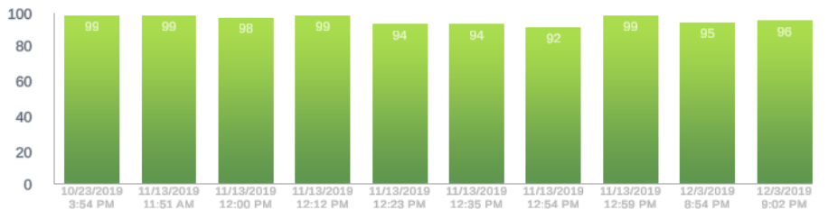**APPENDIX: PITCHVANTAGE SCORES**